THE UNIVERSITY OF AZAD JAMMU & KASHMIR, MUZAFFARABAD


COURSE TITLE | DSA
COURSE CODE | CS-2101
LAB TITLE | DOUBLY LINKED LIST
STUDENT NAME | HASEEB SHEIKH
STUDENT ROLL NUMBER | 2024-SE-31
INSTRUCTOR NAME | ENGR. SIDRA RAFIQUE
SUBMISSION DATE | NOVEMBER 3, 2025

DEPARTMENT OF SOFTWARE ENGINEERING
DSA
Lab 4

Objective:
The goal of this lab is to design and implement a Doubly Linked List (DLL) structure and demonstrate the successful functionality of these operations:
- Inserting a node at the beginning of the list.
- Inserting a node at the end of the list.
- Deleting a node from the beginning of the list.
- Displaying the list in forward and backward directions.

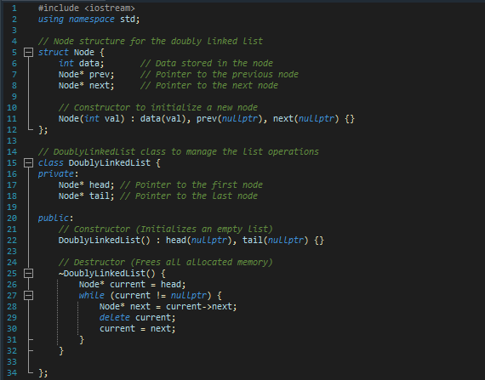
Node & Class Structure:
- This block of code defines the basic structure and memory management for the Doubly Linked List.

- The destructor (~DoublyLinkedList()) is called automatically when a DoublyLinkedList object goes out of scope or is explicitly deleted. Its primary purpose is to prevent memory leaks.
Inserting a node at the beginning of the list
- Code
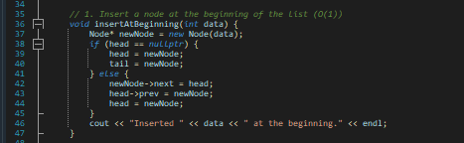

- Output
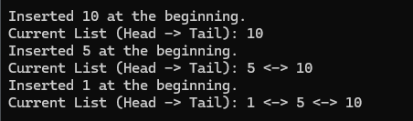

- Main Function
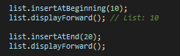

Inserting a node at the End of the list
- Code

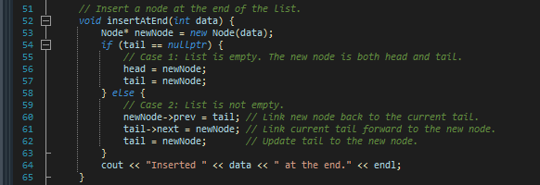

- Output
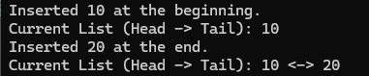

Deleting a node from the beginning of the list
- Code
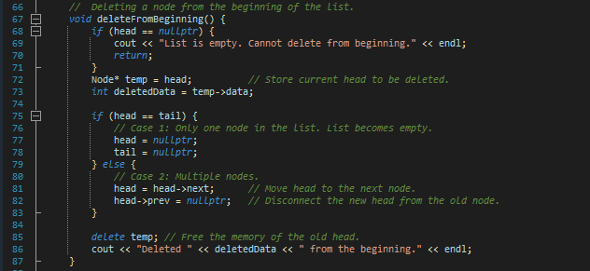
- Output
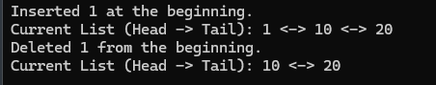

Displaying the list in forward and backward directions

- Code [For Forward]

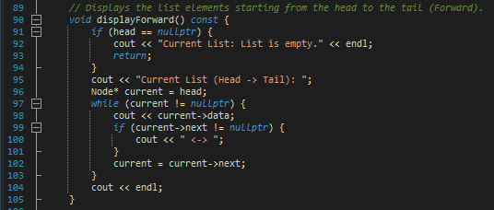

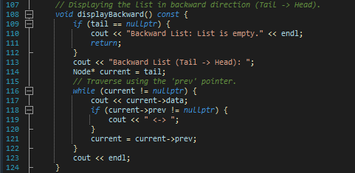
- Code [For Backward]

- Output
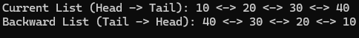

- Main Function
